Assignment 3

Give shell scripts of the following :
1. To find Largest of Three Numbers

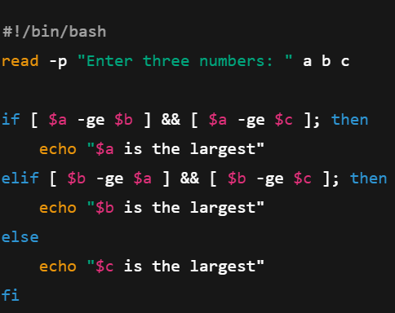
2. To find a year is leap year or not
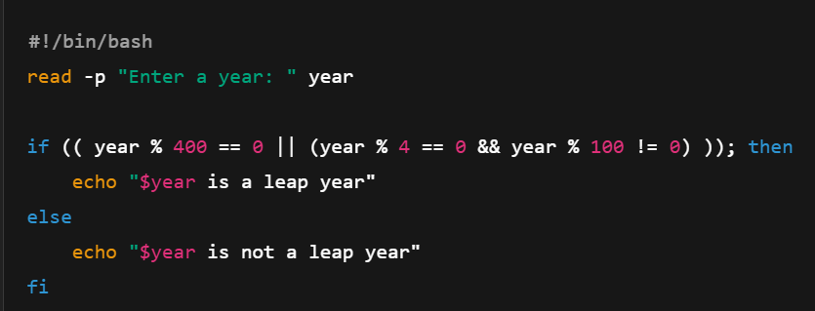

3. To input angles of a triangle and find whether it is valid or not
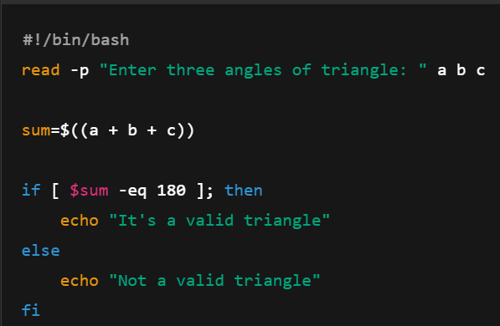

4. To check whether a character is alphabet, digit or special character
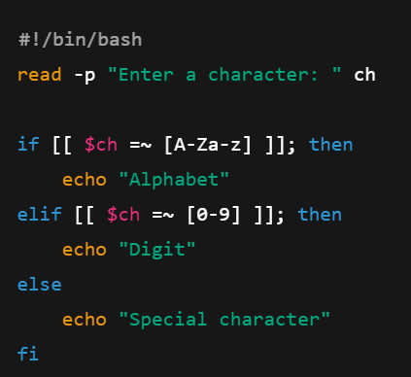

5. To calculate profit or loss
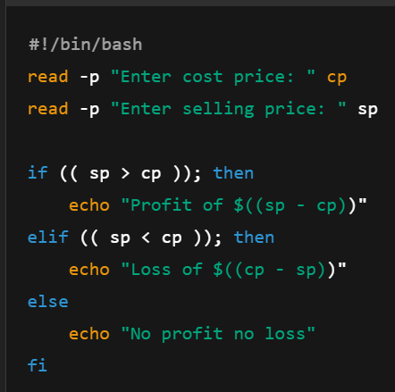

6. To print all even and odd numbers from 1 to 10
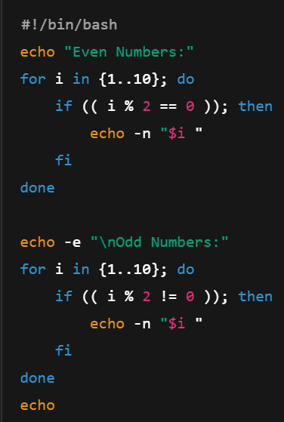

7. To print table of a given number
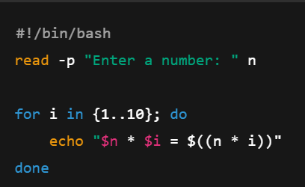

8. To find factorial of a given integer
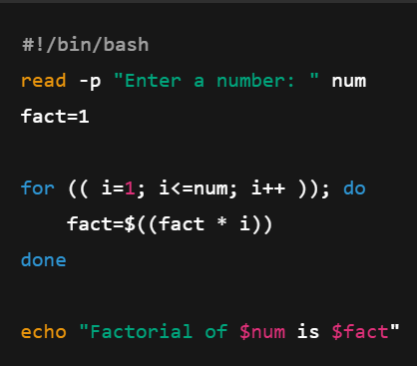

9. To print sum of all even numbers from 1 to 10
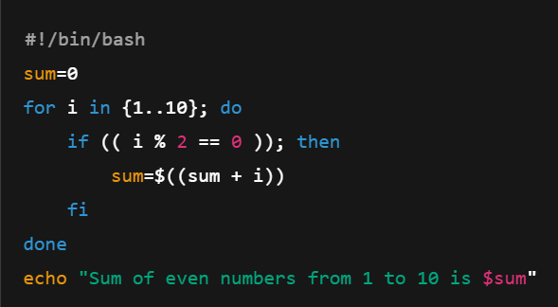

10. To print sum of digits of any number
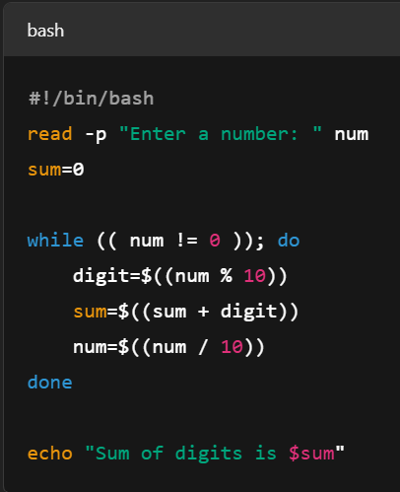

11. To make a basic calculator (add, sub, mul, div)
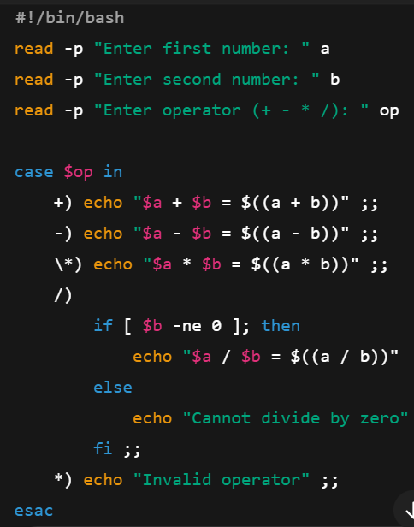

12. To print days of a week
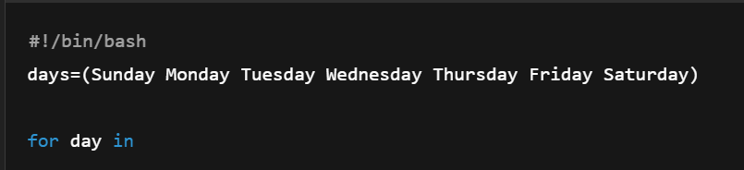

13. To print starting 4 months having 31 days
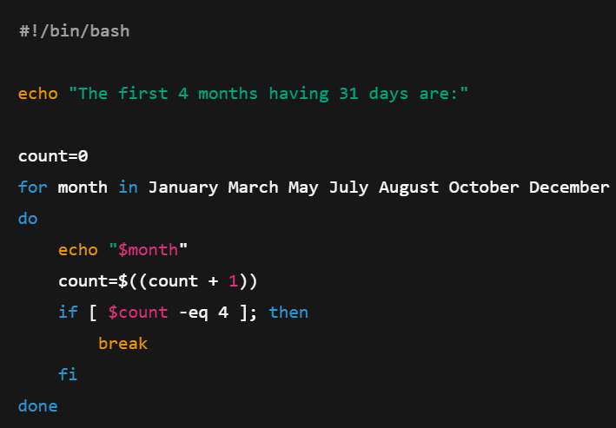

14a. To find given number is Armstrong number or not
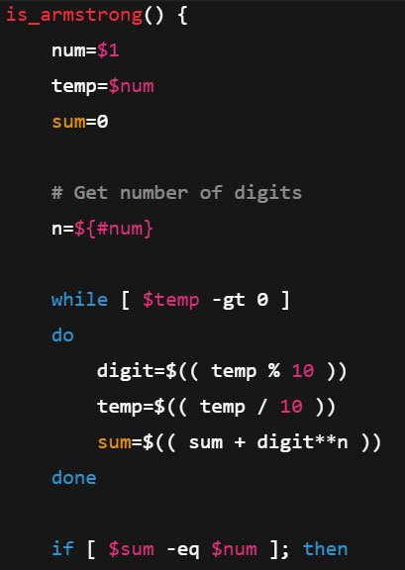
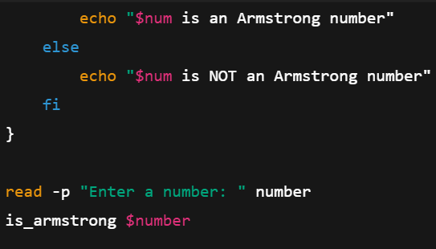

14b. To find whether a number is palindrome or not
